Effective Combat Casualty Care Handoff Operations
(ECCCHO) Training
Instructor Curriculum




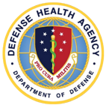
Training Package Curated By: Camilla Knott, PhD;
Kerri Chik, MA;
COL Ramey Wilson, MD, MPH;
Joseph Lopreiato, MD

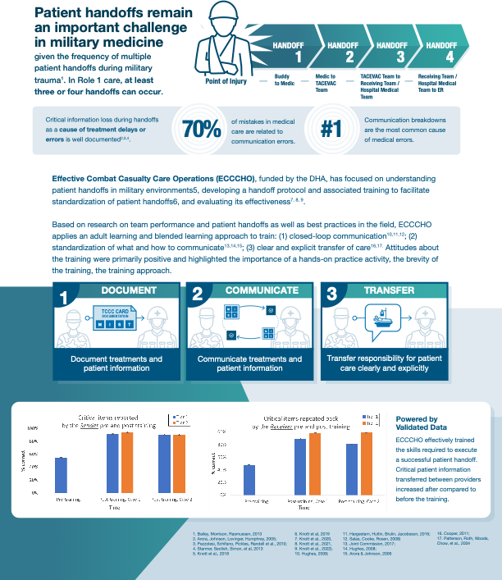

Contents
QUICK REFERENCE GUIDE 4
OPTION 1 5
OPTION 2 6
INSTRUCTOR GUIDE 7
EXAMPLE HANDOFF USING ECCCHO 34
TIER 2 TABLETOP PRACTICE EXERCISE AND SKILLS CHECK SCENARIOS 35
TIER 2 TABLETOP PRACTICE EXERCISE #1 - SITUATION 36
TIER 2 TABLETOP PRACTICE EXERCISE #2 - SITUATION 38
TIER 2 TABLETOP PRACTICE EXERCISE #3 - SITUATION 40
TIER 2 SKILLS CHECK #1 – SITUATION 42
TIER 2 SKILLS CHECK # 2 – SITUATION 44
TIER 2 INSTRUCTOR ASSESSMENT SHEETS 46
APPENDIX 52
KNOWLEDGE TEST ANSWER KEY 54
THE PERFECT STORM SCENARIO (Transcript of Audio recording) 55
TABLETOP EXERCISES AND SKILLS CHECK SCENARIOS 56
TIER 1 TABLETOP PRACTICE EXERCISE AND SKILLS CHECK SCENARIOS 58
TIER 1 TABLETOP PRACTICE EXERCISE #2 – SITUATION 61
TIER 1 TABLETOP PRACTICE EXERCISE #3 – SITUATION 63
TIER 1 SKILLS CHECK #1 – SITUATION 65
TIER 1 SKILLS CHECK #2 – SITUATION 67
TIER 1 INSTRUCTOR ASSESSMENT SHEETS 69

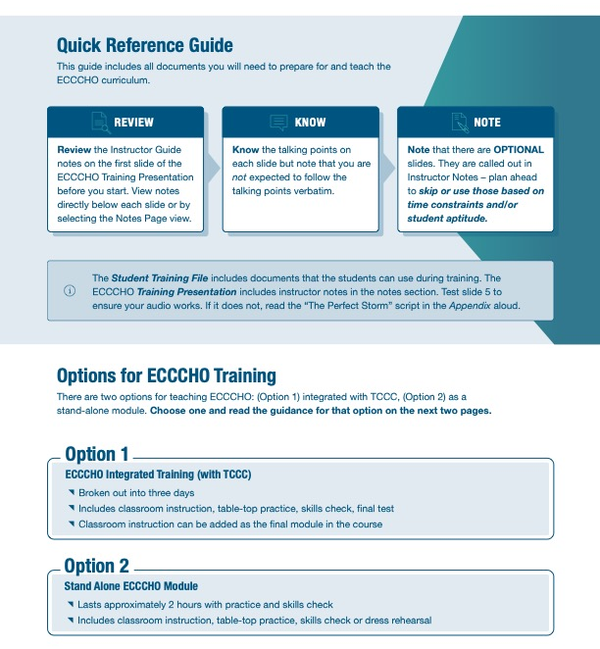
Quick Reference Guide
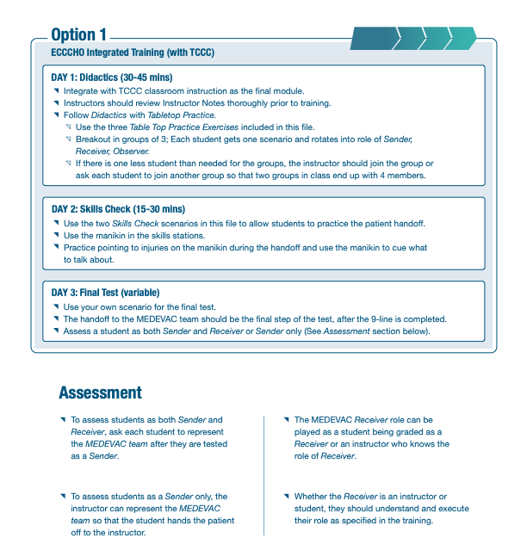
Option 1
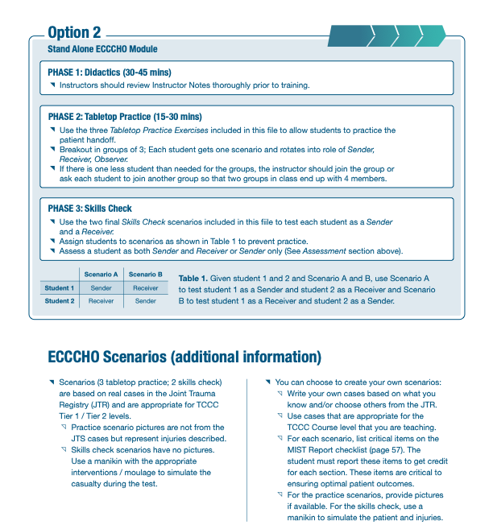
OPTION 2

instructor guide

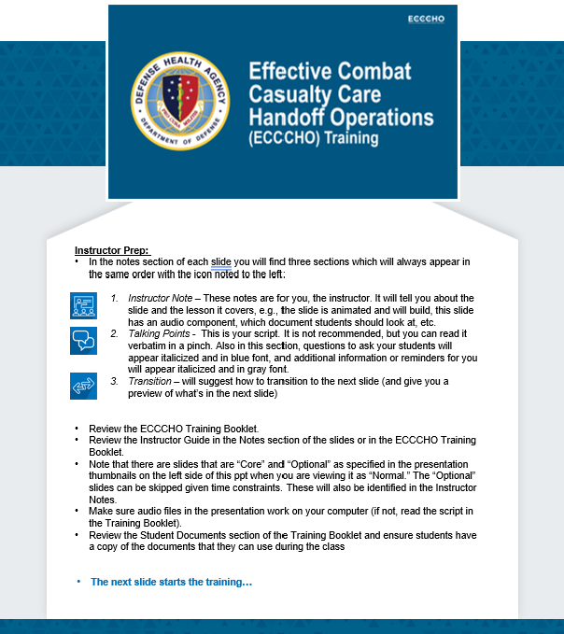

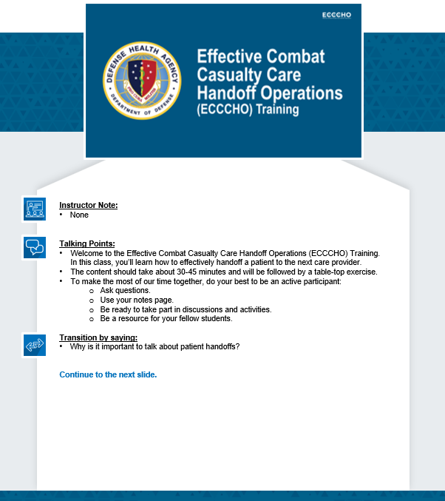

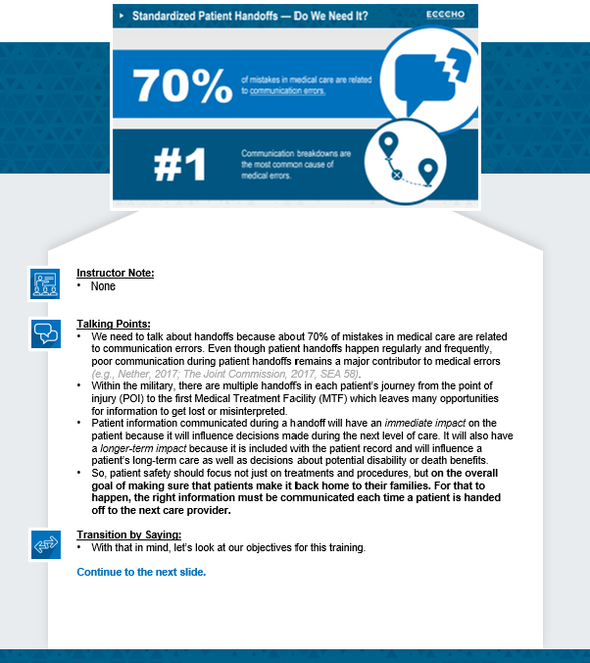
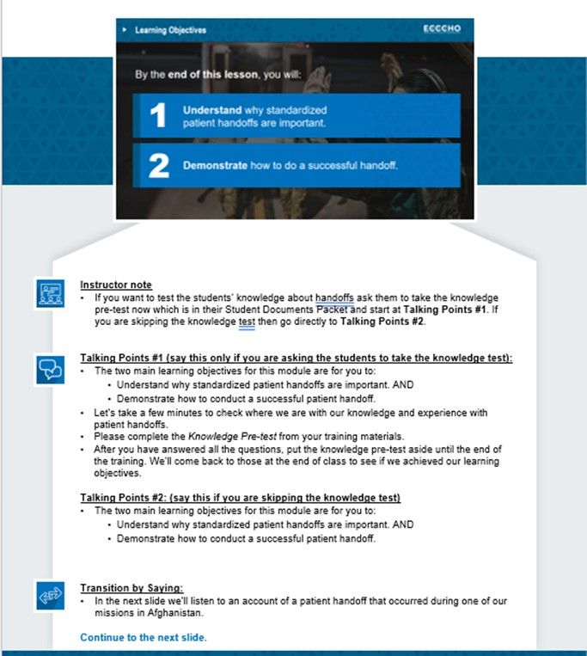
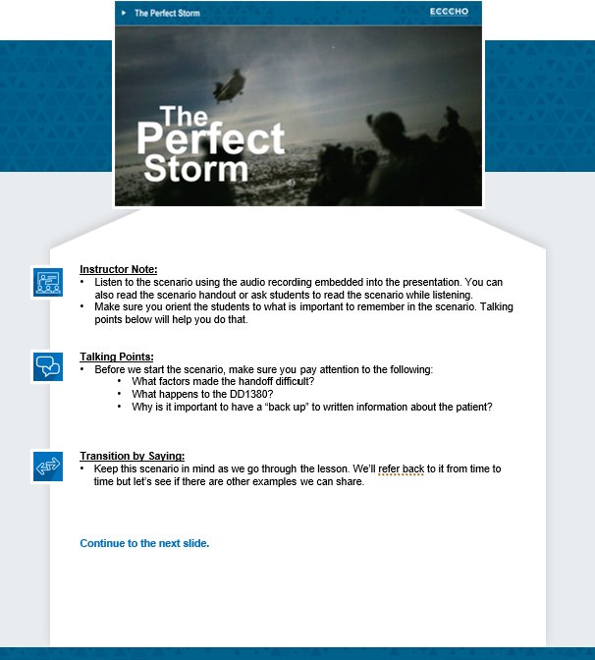
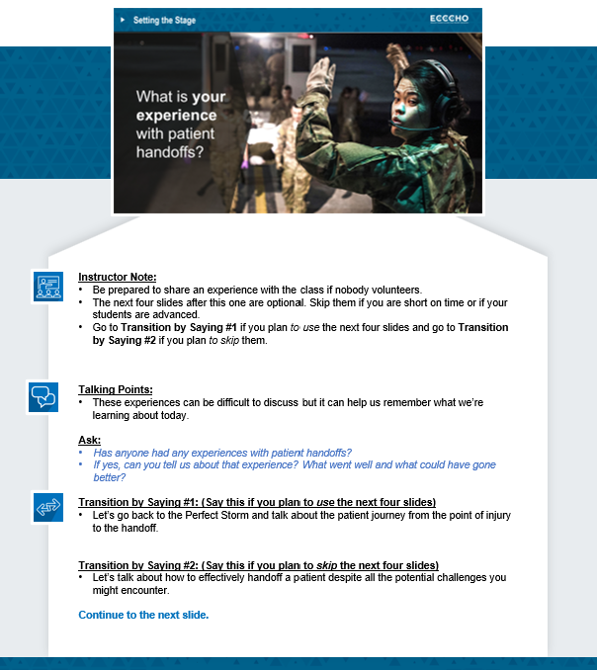

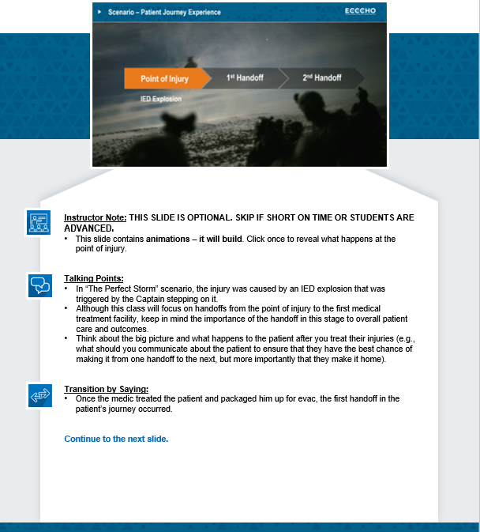

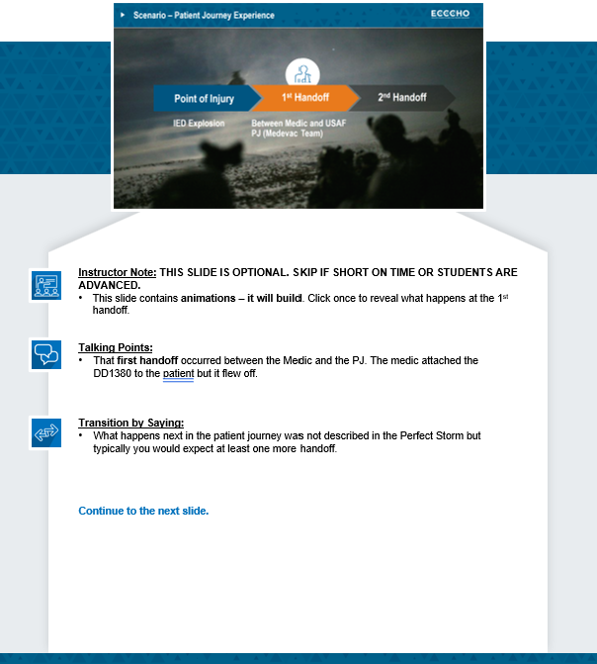

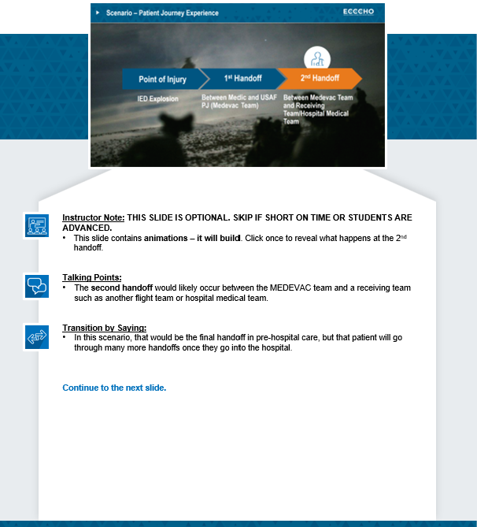

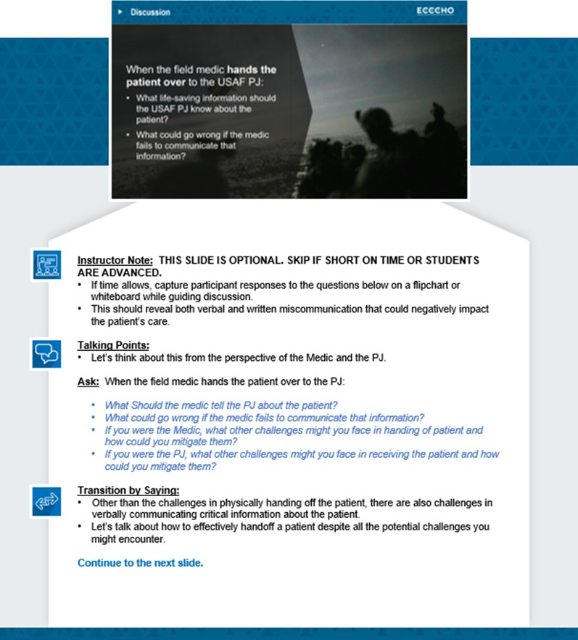

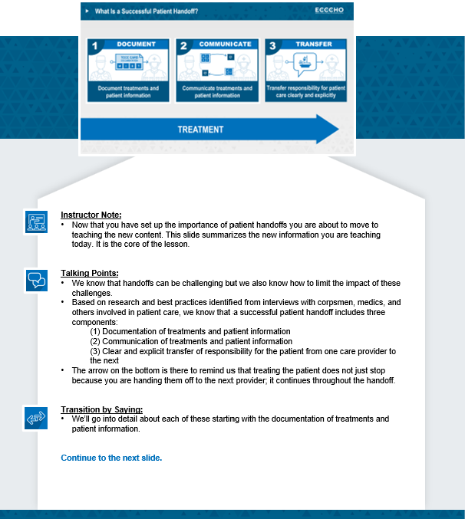

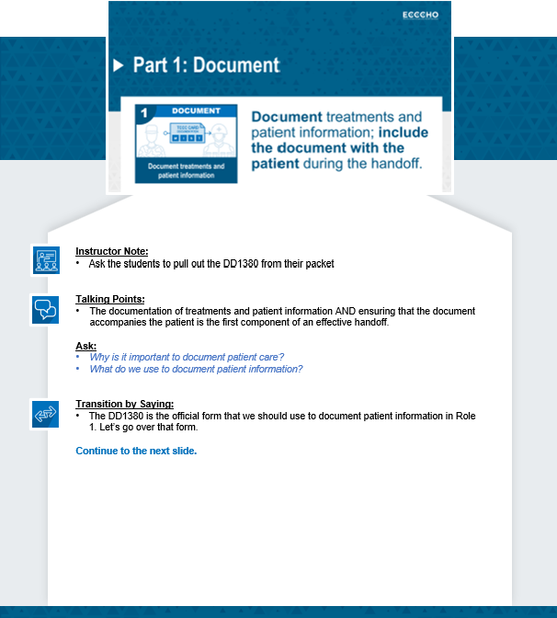

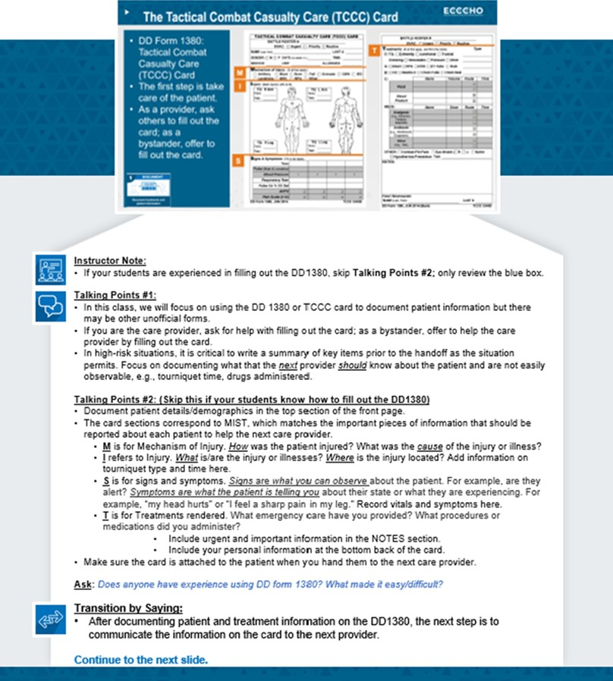

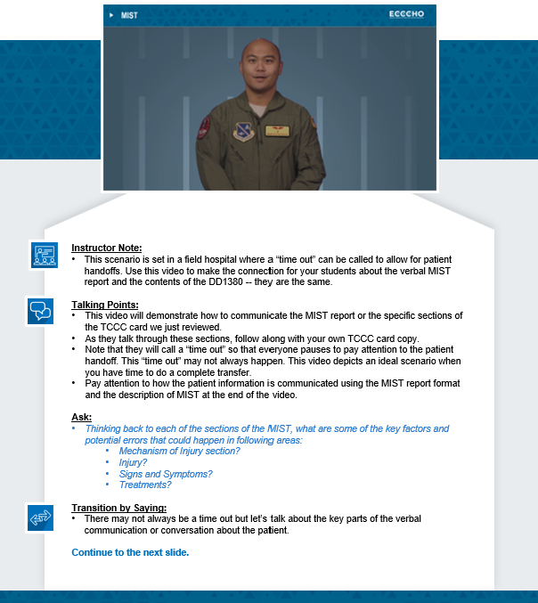

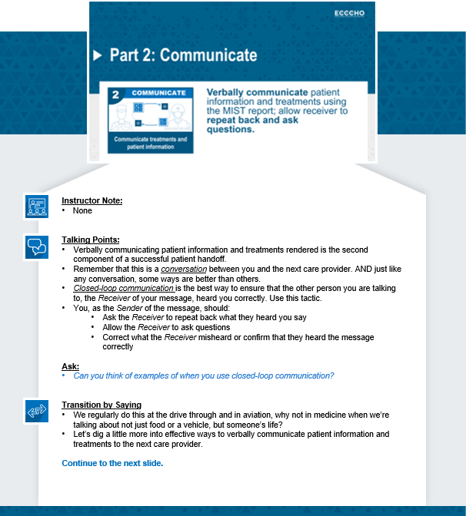

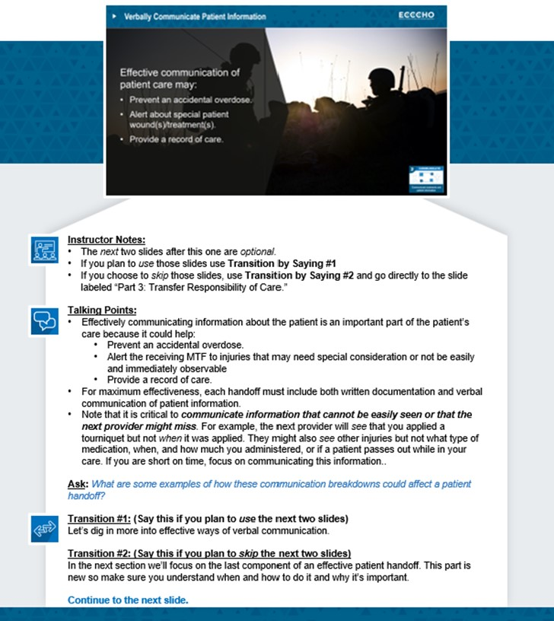

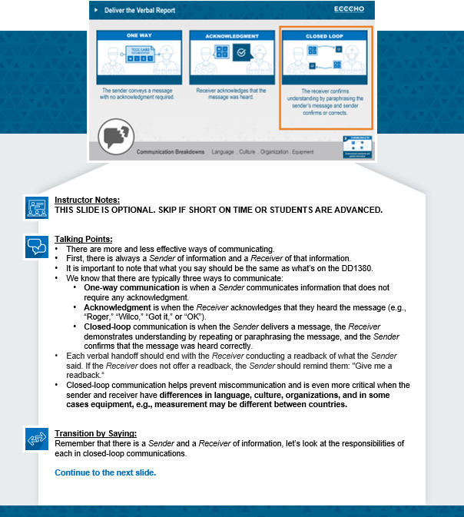

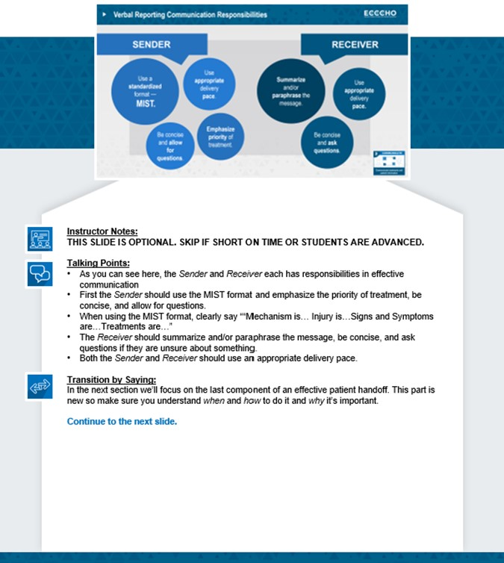

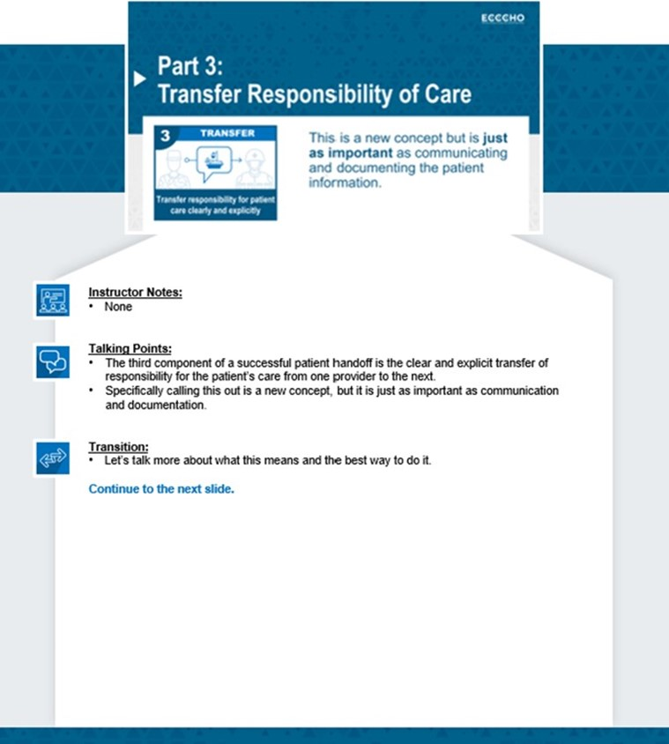

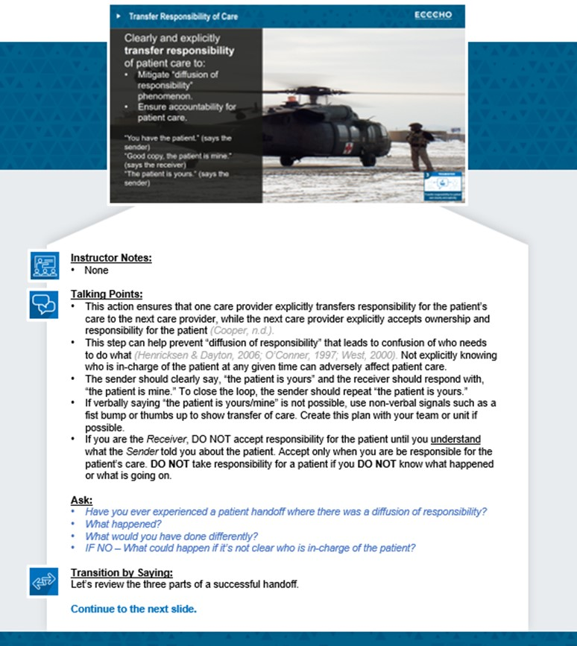

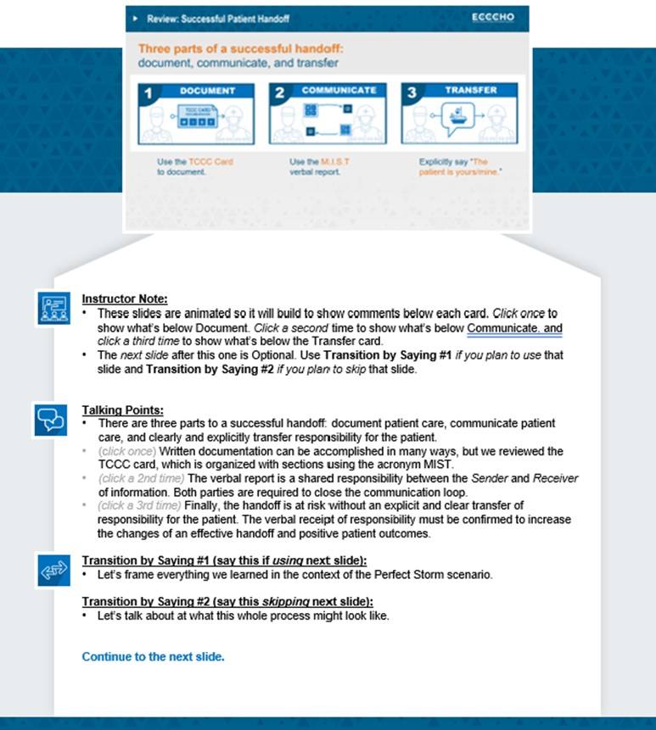

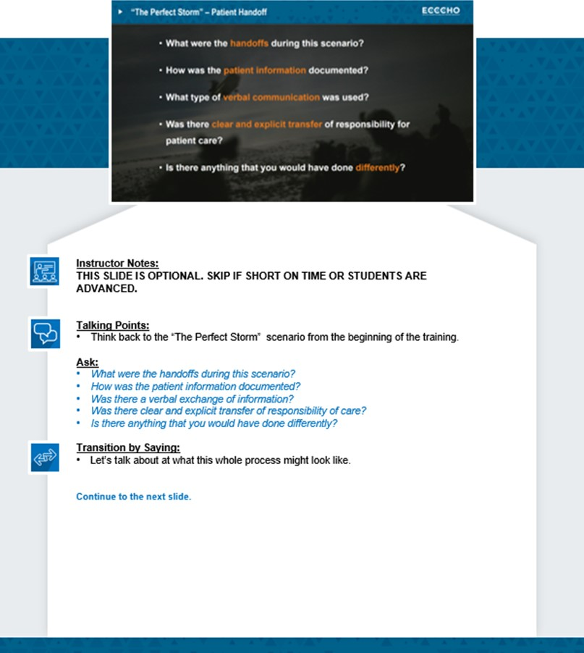

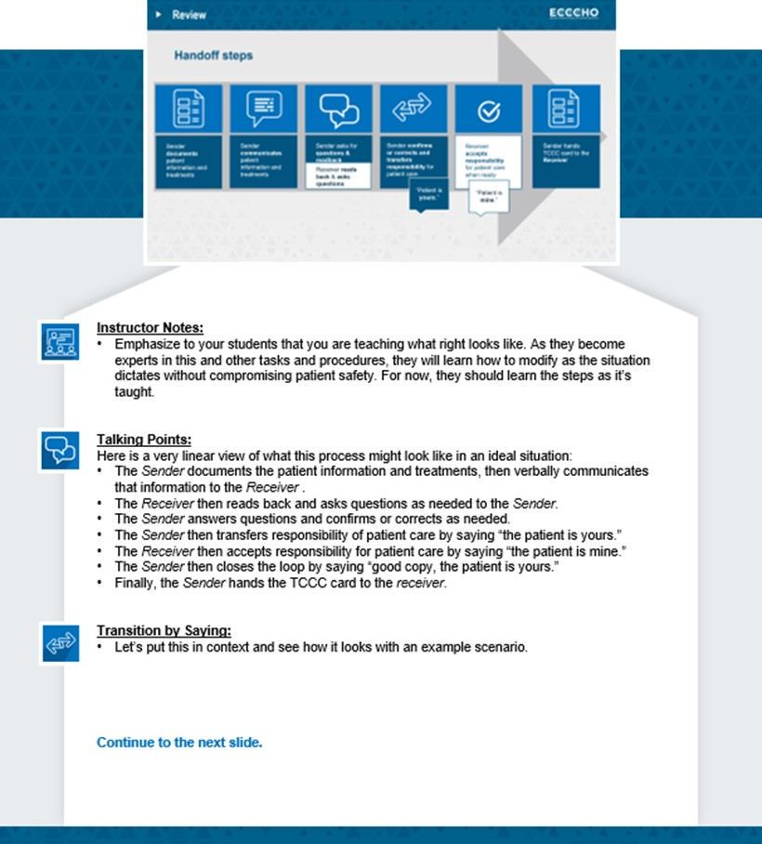

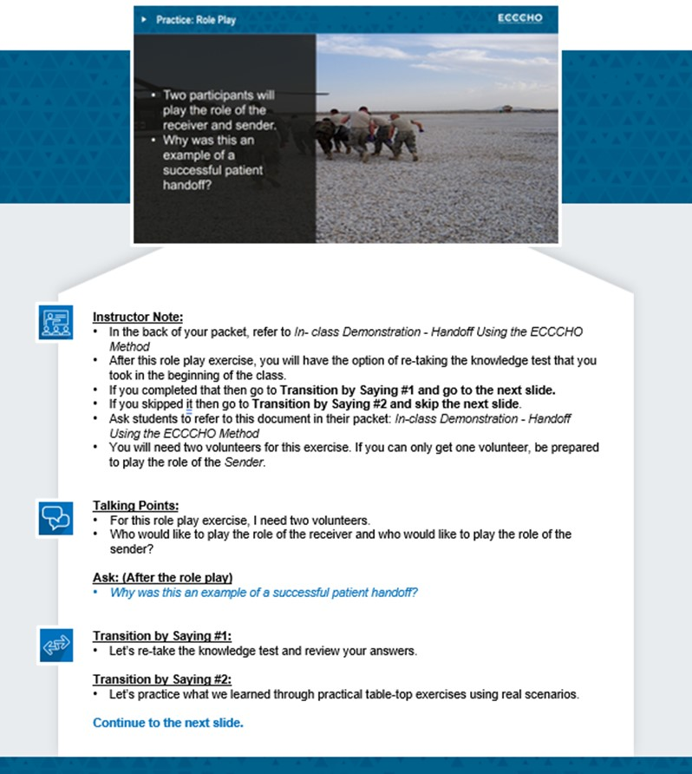

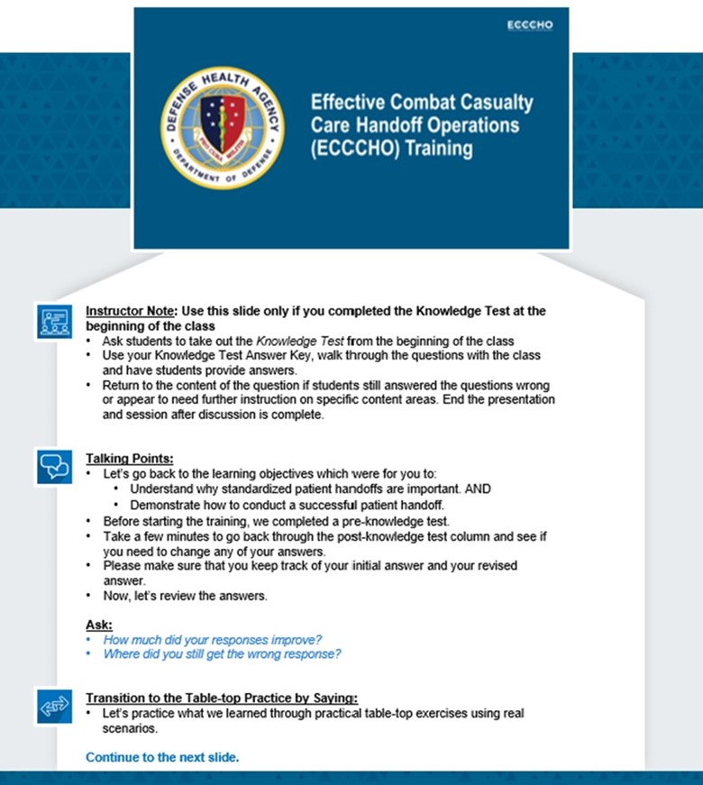

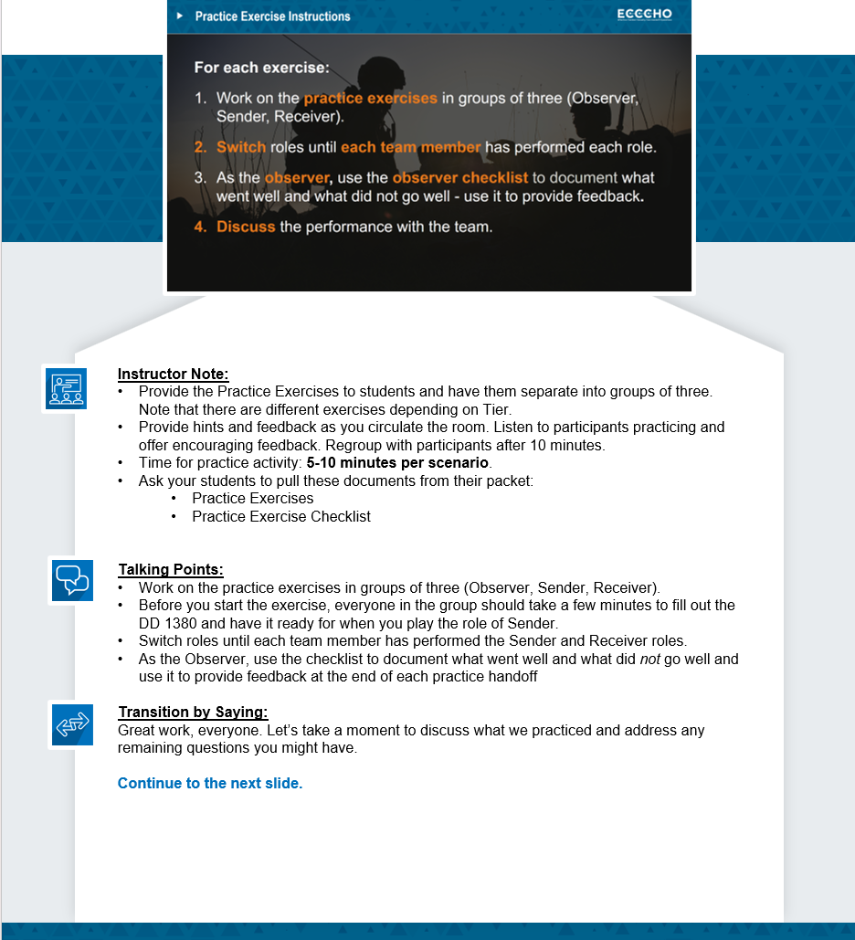

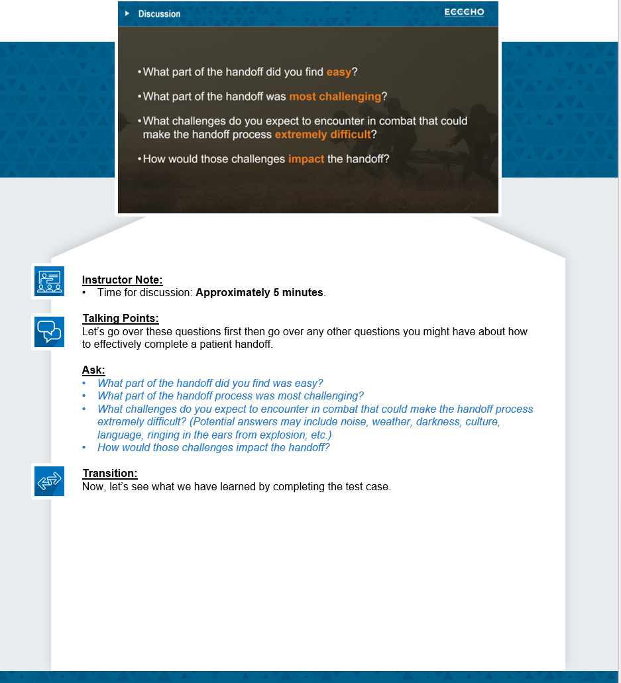

EXAMPLE HANDOFF USING ECCCHO
Instructions: The students will play the role of the sender and the role of the receiver. Be sure to say, “Mechanism is… Injury is… Signs/Symptoms are… Treatments are…” If you are using a manikin, point to areas when speaking to injury and treatment sections. After the role play is completed, give any necessary feedback to the students.
Sender: Are you ready to receive?
Receiver: Yes, I am ready. Present your MIST report.
Sender: We have a 28-year-old male. Battle Roster AB2230.
Mechanism of injury is a fall. He fell 10 feet off the top of a vehicle while doing maintenance. He landed on his feet and hit his head against the vehicle.
Injury is an open fracture on his right leg and a laceration on the back of his head.
Signs/Symptoms are complaints of pain in his leg and head and says that he can’t see in his right eye. He denies passing out.
Treatments are two tourniquets on the right leg and dressings on his head and leg wounds. What are your questions? Read back when ready.
Receiver: Any difficulty breathing or confusion?
Sender: No confusion or difficulty breathing.
Receiver: Is the bleeding controlled?
Sender: Bleeding is controlled with the tourniquet.
Receiver: Okay. We have a 28-year-old male. Mechanism is a fall from a vehicle while doing maintenance. The fall was about 10 feet and he hit his head.
Injuries are an open fracture to the right lower leg. He has a head wound but there was no loss of consciousness.
Signs/Symptoms – He is breathing okay and is complaining of pain and loss of vision in his right eye. He is alert and does not seem to be confused.
For treatments – You placed two tourniquets on his right leg that controlled the bleeding, and you bandaged the leg and head wounds.
Sender: Good read back. The patient is yours (hands over completed TCCC card to receiver).
Receiver: The patient is mine.

TIER 2 TABLETOP PRACTICE EXERCISE AND SKILLS CHECK SCENARIOS

TIER 2 TABLETOP PRACTICE EXERCISE #1 - SITUATION
ID: Taylor Overlook (Battle Roster # TO2231 and Last 4 of SSN is 2231). Male, U.S. Army and assigned to 1-234 Infantry. No known drug allergies (NKDA). Date of Injury: 2 Jan 2010. Time of Injury: 1200L (local). Evacuation Category: Priority.
A 38 y/o male soldier was dismounted and several meters from a vehicle when it exploded. He was on guard duty at the ECP (Entry Control Point) and was turning away from the vehicle when it detonated. He was thrown forward onto his face, injuring his nose and face and causing a significant amount of nasal bleeding. When you arrived by his side to assist him, he was lifting himself off the ground. He was disoriented but it was difficult to determine if this was from the blast or from blood in his eyes. He had significant facial trauma and blood was coming out of his nasal area. There was no evidence of significant blood loss on the ground near him, his airway appeared intact, and he was breathing without difficulty. He was bending over to let the blood from his nose fall onto the ground and was spitting blood out of his mouth. He denied that he lost consciousness. He had a strong radial pulse of 120 and respiratory rate of 18. His pain was 6/10. You gently apply pressure to the areas of bleeding but he is not able to tolerate it due to it making it difficult to breath. You give him his combat pill pack and allow him to maintain a bent over position to protect his airway. You do NOT place a nasopharyngeal airway due to the facial trauma.
A truck pulls up to take him to the aid station and you are told to go with the patient to care for him on the way. You fill out the TCCC on the way and prepare to hand him off to the physician at the aid station. Please give an oral handoff to the Battalion Surgeon using the MIST format.
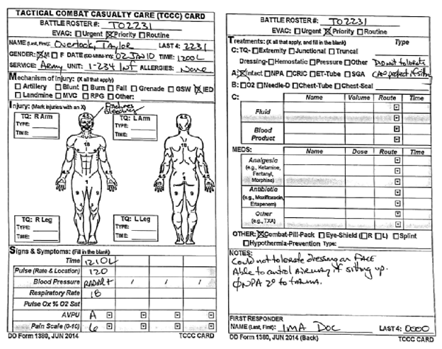

TIER 2 TABLETOP PRACTICE EXERCISE #2 - SITUATION
ID: Timothy Overwatch (Battle Roster # TO2232 and Last 4 of SSN is 2232). Male, U.S. Navy and assigned to Security Force. No known drug allergies (NKDA). Date of Injury: 3 Jan 2010. Time of Injury: 1200L (local). Evacuation Category: Urgent.
A 22 y/o male sailor was a passenger in a MRAP (Mine-Resistant, Ambush-Protected) vehicle when a vehicle-borne IED detonated just prior to impacting the MRAP. The MRAP was lifted into the air and rolled over. After extracting him from the vehicle, he told you that he had no loss of consciousness but severe pain in his right lower leg and left ankle. Your assessment revealed an open fracture of the right lower extremity that was bleeding. You placed a tourniquet proximal to the right leg and put a dressing over the open wound/exposed bone. The left ankle looked dislocated or fractured, but the skin was intact. There was no other evidence of bleeding. The patient was alert, spoke in complete sentences, and was asking for some pain medication. The medic came by to start assessing him, but she was called away to care for another patient. She quickly returned to tell you to finish evaluating the patient, get him on a litter and to prepare to hand him off to the flight medic when they arrive. She stated that she expected to have her hands full with the other patient.
As directed, you get the patient on a litter without difficulty and splint his left ankle, which significantly improves his pain from 10/10 to 8/10. You give him his combat wound medication pack. This further reduces his pain from 8/10 to 6/10 and he seems more relaxed. His respiratory rate is 18 and his radial pulse is 115 and strong. You put him in a hypothermia prevention/management kit (HPMK) and prepare him for aeromedical evacuation.
The MEDEVAC helicopter has arrived, and the medic is still stabilizing the other casualty. The flight medic comes over to you and you hand him the TC3 card you have completed. Please give the flight medic your oral handoff using the MIST format.
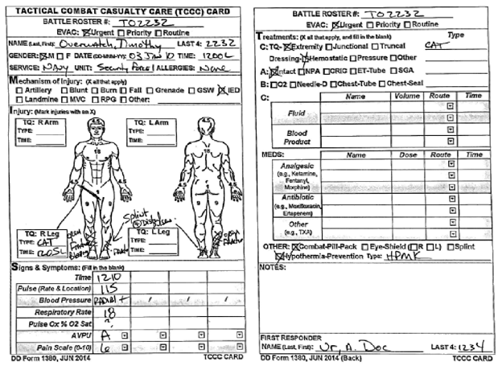

TIER 2 TABLETOP PRACTICE EXERCISE #3 - SITUATION
ID: Tahir Overwatch (Battle Roster # TO2233 and Last 4 of SSN is 2233). Male, U.S. Army and assigned to 1-234 Infantry. Allergy to Penicillin (PCN). Date of Injury: 4 Jan 2010. Time of Injury: 1200L (local). Evacuation Category: Urgent.
A 25 y/o male soldier stepped on a pressure-plate land mine while on a dismounted patrol. He is one of several casualties from this explosion. As you arrived to help him, he was not moving and not responding to your questions. He was lying on the ground, and there was a moderate amount of blood on the ground by his legs. His left leg was lying at an odd angle, and blood was coming out of wounds from both legs. You immediately worked to place tourniquets on both lower extremities. As you continued your blood sweeps, you found a bleeding wound in the upper left upper extremity and placed a tourniquet on the left arm as well. The medic comes over to assess the patient, who only responds to painful stimulation and is taking shallow respirations. Radial pulse is hard to measure but rapid (in the 120s). The medic directs you to place a nasopharyngeal airway and assist the patient with breathing using a Bag Valve Mask. He begins to dress the wounds, but gets an urgent call to come assist with one of the other casualties. He tells you that he has to go but for you to call him if you have any problems. You notice that the patient has a drug allergy tag for penicillin.
With the help of another Combat Lifesaver, you get the patient into a hypothermia prevention kit and onto a litter simultaneously. You put dressings on the arm and both leg wounds and splint the left leg. The patrol moves a short distance to a hasty landing zone and the MEDEVAC aircraft arrives. The medic is still busy caring for the other casualties as the flight paramedic comes over to you. You point to where you attached the TC3 card to the patient. Please give an oral handoff to the flight paramedic using the MIST format.
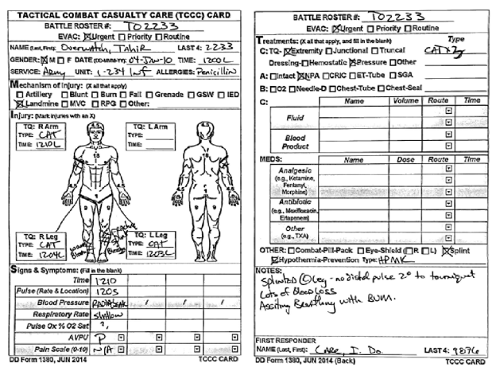

TIER 2 SKILLS CHECK #1 – SITUATION
ID: Tara Overwatch (Battle Roster # TO2234 and Last 4 of SSN is 2234). Female, U.S. Army and assigned to 1-234 Infantry. No known drug allergies (NKDA). Date of Injury: 5 Jan 2010. Time of Injury: 1200L (local). Evacuation Category: Urgent.
A 22 y/o female in your squad sustained multiple gunshot wounds to the right arm, chest, and right upper thigh when your dismounted patrol was ambushed outside the base. After your squad maneuvered through the ambush, you returned to assist the wounded and you found her trying to apply a tourniquet to her right upper thigh. She was alert, quite vocal with her frustration at being injured, and thankful for your offer to help her. She says she is in extreme pain. Your assessment reveals bleeding in the right upper extremity from a gunshot wound in arm with entrance and exit wounds and a gunshot wound to the right anterior chest with no exit wound. On her leg, there is a gunshot wound and exit wound on the upper thigh. There is a significant amount of blood on the ground under her leg. You assist her by tightening the tourniquet on the right thigh she was applying, which has stopped the flow of arterial blood. You place a tourniquet on her right upper arm and an occlusive dressing over the wound on her chest. Her radial pulse is 115 and strong; her respiratory rate is 18. You give her a combat pill pack. You get her onto a litter and place dressings on her arm and thigh wounds and get her into a hypothermia prevention management kit. While awaiting plans to move her to a centralized location, you fill out the TC3 card.
Your platoon medic heads your way to check on your patient and to see if you need assistance. He wants to consolidate all the patients at the CCP (Casualty Collection Point) to prepare them for evacuation. You work together to move the patient to the CCP, but you are needed back on the line for security, as your leadership is concerned about another attack. The medic quickly reviews your TC3 card and asks you for a handoff brief. Please give an oral handoff to the medic using the MIST format.
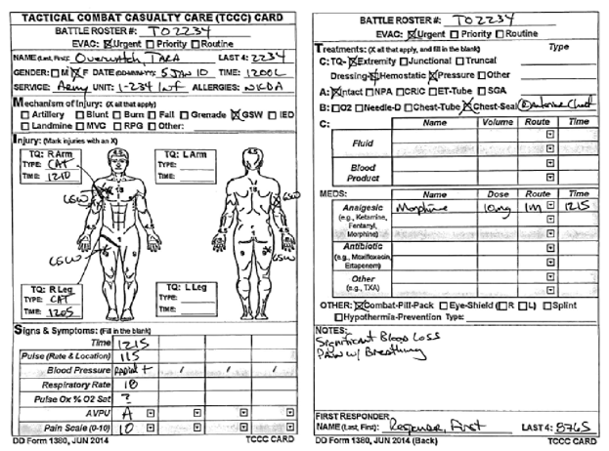

TIER 2 SKILLS CHECK # 2 – SITUATION
ID: Taavon Overlord (Battle Roster # TO2235 and Last 4 of SSN is 2235). Male, U.S. Army and assigned to 1-234 Infantry. No known drug allergies (NKDA). Date of Injury: 6 Jan 2010. Time of Injury: 1300L (local). Evacuation Category: Urgent.
You were on patrol when your medic, a 25 y/o male, seemed to disappear in a cloud of dust 30 feet in front of you. After the dust settled, it was clear that your squad was struck by an improvised explosive device (IED). Once the scene was secure, you moved to him and were the first person at his side. You found his left lower leg was completely blown off at the level of the mid-shin and his right leg is flopping around with an open fracture and bones sticking out. He appeared confused but responded to your voice. He was not able to answer your questions because he was having difficulty breathing and catching his breath. You place tourniquets on both legs, but it appears that he lost a lot of blood before you got the tourniquets on. Your squad leader coordinates for a litter to be assembled and you and your teammates move him to cover. You complete your blood sweeps and find no additional bleeding or wounds. You observe unequal rise and fall of the chest with tracheal deviation to the patient’s right side. You perform a needle decompression on the right side, which improves the patient’s breathing, and he becomes alert. His radial pulse is 140 and not very strong. You decide not to give pain medications. Evacuation is delayed due to security and the decision is made to move him by ground back to the base. In the back of the truck, you put him in a hypothermia prevention/treatment kit and splint his right leg fracture. You place pressure dressings on the wounds on both the right and left legs and administer his combat wound medicine pack.
You arrive at the aid station. Fill out the TCCC card and hand off the patient to the Battalion Surgeon using the MIST form.

TIER 2 INSTRUCTOR ASSESSMENT SHEETS

TIER 2 SKILLS CHECK SCENARIO #1
Training Date: _____________ Instructor Name: _______________
Sender ID:_________________ Receiver ID:____________________
Instructions: Check off the items you hear in the verbal handover to the items listed below.
MIST REPORT
DD1380 Section | Critical Items | Sender | Receiver
- Mechanism  (__ Item total) | Multiple gunshot wounds sustained from ambush
- Injury  (__ Items total) | Gunshot wound to right arm
- Injury  (__ Items total) | Gunshot wound to right thigh
- Injury  (__ Items total) | Gunshot wound to right side of anterior chest
- Signs/Symptoms  (__ Items total) | Conscious/alert/speaking
- Signs/Symptoms  (__ Items total) | Severe bleeding/loss of blood
- Signs/Symptoms  (__ Items total) | Pain with breathing
- Treatment  (__ Items total) | Tourniquet on right leg
- Treatment  (__ Items total) | Tourniquet on right arm
- Treatment  (__ Items total) | Occlusive dressing on anterior chest flank
- Treatment  (__ Items total) | Dressing on right arm
- Treatment  (__ Items total) | Dressing on right thigh
- Treatment  (__ Items total) | Combat pill pack
- Treatment  (__ Items total) | Hypothermia prevention management kit
Critical items total:
Additional Comments and Observations:

TIER 2 SKILLS CHECK SCENARIO #2
Training Date: _____________ Instructor Name: _______________
Sender ID:_________________ Receiver ID:____________________
Instructions: Check off the items you hear in the verbal handover to the items listed below.
MIST REPORT

DD1380 Section | Critical Items | Sender | Receiver
- Mechanism  (1 Item total) | Command-detonated IED
- Injury  (2 Items total) | Left lower limb traumatic amputation/blown off
- Injury  (2 Items total) | Right leg open fracture, bones sticking out
- Signs/Symptoms  (3 Items total) | Confused/responding only to voice stimuli
- Signs/Symptoms  (3 Items total) | Difficulty speaking/catching his breath/unequal rise and fall of chest, tracheal deviation
- Signs/Symptoms  (3 Items total) | Severe bleeding/loss of blood
- Treatment  (8 Items total) | Tourniquet on left leg
- Treatment  (8 Items total) | Tourniquet on right leg
- Treatment  (8 Items total) | Needle decompression on right side of chest
- Treatment  (8 Items total) | Placed dressing on stump of left leg
- Treatment  (8 Items total) | Splint on the right leg
- Treatment  (8 Items total) | Placed dressing on right leg wound
- Treatment  (8 Items total) | Hypothermia prevention/treatment kit
- Treatment  (8 Items total) | Combat pill pack
Key items total:
Additional Comments and Observations:
SKILLS CHECK SCENARIO # _____________ (Use this form if creating your own scenario. Add # of critical item total for each section in DD1380 section and critical items in Critical Items column)
Training Date: ______________ Instructor Name: _______________
Sender ID:__________________ Receiver ID:____________________
Instructions: Check off the items you hear in the verbal handover to the items listed below.
MIST REPORT
DD1380 Section | Critical Items | Sender | Receiver
- Mechanism
(__ Item total)
- Injury
(__ Items total)
- Signs/Symptoms
(__ Items total)

- Treatment
(__ Items total)
Critical items total:
Additional Comments and Observations:

Handoff Skills Assessment Form (Use with any scenario)
- Do the receiver and sender use closed-loop communication?

 | Receiver verbally acknowledges message was received. |  | Recipient verbally acknowledges and repeats back task-related message. |  | Recipient verbally acknowledges and repeats back message accurately and completely; verbally requests clarification or verification from the sender when needed.
Receiver
 | The sender initiated the handoff without asking if the receiver was ready to initiate. |  | The sender asked the receiver if they were ready for the handoff, but did not acknowledge questions/concerns from the receiver or did not close the loop. |  | The sender asked if the receiver was ready for the handoff and acknowledged questions/concerns of the receiver or closed the loop.
Sender
- Please rate the degree to which a transfer of responsibility occurred during the handoff:

 | Current care provider and subsequent care provider did not confirm transfer of responsibility. |  | Current care provider confirmed transfer of responsibility, but subsequent care provider did not confirm retrieval of responsibility. Vice versa. |  | Both current and subsequent care providers confirmed transfer of patient care responsibility.
Transfer of responsibility:

- Please rate the degree of completion and reception of the handoff form:

 | The sender did not complete the patient information form and the form was not handed over to the receiver. |  | The sender completed the patient information form and did not hand it to the receiver. |  | The sender completed the patient information form and handed it over to the sender.
Completion and reception of handoff form:

- Did the receiver ask the sender any clarifying questions about the handover?
  - Yes
  - No

What clarifying questions were asked? ________________________________________________________________________________________________________________________________________________________________________________________________________________
________________________________________________________________________________________________________________________________________________________________________________________________________________

APPENDIX

Instructor Documents
ECCCHO Training PowerPoint Presentation Deck
ECCCHO Training Booklet (Instructor and Student) | This booklet includes the background on ECCCHO along with a general description of the components of the ECCCHO training, Instructor Documents that include images of the slides in the Presentation Deck, and the Instructor Guide, which is available in the Notes section of the Presentation Deck.
ECCCHO Instructor Guide (IG) | This is available in the Notes section of the Presentation Deck. It includes a complete script and example questions or probes.
Perfect Storm Scenario | Scenario script that can be read if there is no audio during the presentation. Students will also have the scenario script in their packet to allow them to follow along as they listen.
Example Handoff Using ECCCHO | Handoff script to be used during training. Students should read the script during a role-playing exercise and then discuss the different parts of the handoff.
Knowledge Test Answer Key | Answers to the knowledge test, which can be administered before training to identify baseline knowledge and as a knowledge check test after the training.
Perfect Storm Scenario | Scenario script to follow with the audio or to read if audio is not available.
Tabletop Exercises | Includes the background information about a case, completed DD1380 card, and additional guidance on how to use practice exercises.
Skill Checks Scenarios | The background information and completed DD1380 card to use during test out.
Instructor Assessment Sheets | Criteria for instrcutors to review and assess students.
Student Documents
Presentation with Notes Pages | PowerPoint presentation thumbnails with space for students to take notes.
Knowledge Test | Knowledge test, which can be administered before training to identify baseline knowledge and as a knowledge check test after the training.
Perfect Storm Scenario | Scenario script to follow with the audio or to read if audio is not available.
Example Handoff Using the ECCCHO Method | Handoff script to be used to demonstrate a successful patient handoff during the training.
Tabletop Exercises and Skills Check Scenarios | Includes the background information about a case, completed DD1380 card, and additional guidance on how to use practice exercises.
Practice Exercise Checklist | List of key components to pay attention to during the practice exercise and to use to guide feedback.

KNOWLEDGE TEST ANSWER KEY

- What are the key components for a successful patient handoff?
  - Name; mechanism of injury
  - The patient; responsibility of care
  - The patient; point of injury
  - Patient information; transfer of responsibility for patient care

- The most effective way to transfer information with the patient is through both documentation and verbal communication of patient information and treatments.
  - True
  - False

- The TCCC Card (DD Form 1380) can be broken down into MIST. What does each letter stand for?
  - Mechanism of Injury, Injury, Signs/Symptoms, Treatments
  - Medicine, Injury, Sound, Talking
  - Medicine, Information, Signs/Symptoms, Treatments
  - Mechanism of Injury, Injury, Surgery, Trauma

- The verbal report is a shared responsibility between the report ________ and ________.
  - Patient and Medic
  - Sender and Receiver
  - Patient and Receiver
  - Sender and Medic

- Effective verbal communication is important because it can help with:
  - Preventing an accidental overdose
  - Alerting about special patient wound(s)/treatment(s)
  - Providing a record of care
  - All of the above
  - None of the above

- Clear and explicit transfer of responsibility for patient care is critical because it can help to mitigate:
  - Forgetting
  - Patient movement
  - Accidental overdose
  - Diffusion of responsibility

- ________ communication is when the sender delivers a message, the receiver verbally confirms they understood what was communicated, and the sender confirms that the receiver heard the right message.
  - Open-loop
  - One-way
  - Closed-loop
  - Two-way

- What are differences that can cause communication breakdowns?
  - Language
  - Culture
  - Equipment
  - Organizations
  - All of the above
  - None of the above

THE PERFECT STORM SCENARIO (Transcript of Audio recording)
The Perfect Storm
In 2011, my ODA was tasked with providing Village Stability Operations in Southern AFG. There was a very strong insurgent presence and influence in the Zhari region. While we were there, we conducted a reconnaissance mission of a known Taliban checkpoint and meeting site. We watched approximately 30 military-aged males chanting anti-American rhetoric while carrying RPGs, AK47s, PKMs, and an 82mm recoilless rifle. This cell was responsible for many US deaths and injuries in the area.
After a few days of planning, we initiated a late-night raid and occupation of their checkpoint. We entered the grape rows with four US Special Forces soldiers, two Navy EODs, two interpreters, and ten Afghan Commandos. During the infill, approximately 200 meters from the checkpoint, an explosion occurred. We missed an IED during the sweep, and someone in the middle of the linear formations had stepped on it. Through the dust and flying debris, I watched a backlit grey silhouetted lone figure in a slow-motion one-legged ballet. I could hear screaming as I maneuvered around commandos left and right to maintain eyes on the casualty.
The first call went up from behind me. “Higher, this is Lower, break, I think the Captain just stepped on it.” I called over internal comms: “This is 35D1…Clear me in... Over… Any available? This is 35D1… Clear me in, I need to get to him NOW!” My junior rushed in to treat the two casualties. He ended up treating the first casualty with a secondary IED directly behind him. Unable to move and unable to help, he watched as the other soldier (who had a higher likelihood of survival) bleed out from bilateral AKA. After repeated pleas and returned silence, I decided to move to the patient. Pushing my way forward, I found the Navy EOD attachment attempting to place a SOF-T tourniquet on a partial BKA. I took the tourniquet from him, placed it high and tight, and continued my assessment. We were now exposed.
The element of surprise was lost. The ICOM chatter went berserk as they rallied the insurgents to move on our position. Although we were still conducting care under fire, a Special Operations aviation unit consisting of two Chinooks with a medical team on board was in the area. They were returning from a mission when they were diverted to help us. The Chinook stabilized overhead, and a PJ came down on a jungle penetrator to assist with care and prep for evacuation. When he saw my patient, he blurted out, “Oh man, he is really messed up!” A ridiculous statement of the obvious. Kudos to the crew of that bird, though. They sat her down in an open field that had not been cleared, even knowing the potential IED threat, all while dodging RPGs and taking PKM fire. The PJ, my Team Leader, the second Navy EOD, the interpreter, and I crawled out of the grape rows to load the patient onto the Chinook. The enemy was attempting to flank the four of us from the north and south. They were trying to kill us in the open and shoot the bird while she was stationary on the ground.
We loaded the patient quickly, as security was paramount at this time, and we were detached from our main element. I handed off the patient to the second PJ, but with all the gunfire and the flight noise, it was not the most coherent handoff – there was a lot of yelling and sign language. I touched all interventions and went to point at the TCCC card that I had placed around his wrist, but it was gone. It must have gotten blown away in the maelstrom of downwash or got caught on something as we scrambled through the grape rows. Luckily, I had written vitals on his face in permanent marker and felt like we had a good verbal handoff. Fortunately, this patient is alive today because of the care he received.
As a BKA, he remembers very little from that night. I cannot tell you what would have happened if I didn’t notice that the TCCC card was gone, or if the second PJ wasn’t able to hear my handover. I just knew that despite all of the obstacles, the second PJ needed to have all the imperative patient information. I needed to do my best to give him a chance to make it back home again, alive.

TABLETOP EXERCISES AND SKILLS CHECK SCENARIOS
Instructions: The Tabletop Exercise and Skills Check Scenarios are for practice and are not a graded event. Hand out the three scenarios to all students. All of the students will fill out the DD1380 and then complete the handout.
TEST SCENARIO IDENTIFIER: _____
Training Date: ________________ Instructor Name: ___________________
Sender ID: ___________________ Receiver ID: ______________________
Instructions: Check off the items you hear in the verbal handover to the items listed below.
MIST REPORT |  | Sender | Receiver
- Mechanism
(_ Item total)
- Injury
(_ Items total)
- Signs/Symptoms
(_ Items total)

- Treatment
(_ Items total)
Key items total:
Additional Comments and Observations:

TIER 1 TABLETOP PRACTICE EXERCISE AND SKILLS CHECK SCENARIOS
TIER 1 TABLETOP PRACTICE EXERCISE #1 – SITUATION
ID: Taylor Overlook (Battle Roster # TO1231 and Last 4 of SSN is 1231). Male, U.S. Army and assigned to 1-234 Infantry. No known drug allergies (NKDA). Date of Injury: 2 Jan 2010. Time of Injury: 1200L (local).
38 y/o male soldier was dismounted and thrown several meters from a vehicle when it exploded. He was on guard duty at the ECP (Entry Control Point) and was turning away from the vehicle when it detonated. He was thrown forward onto his face, injuring his nose and face and causing a significant amount of nasal bleeding. When you arrived by his side to assist him, he was lifting himself off the ground. He was disoriented, but it was difficult to determine if this was from the blast or from blood in his eyes. He had significant facial trauma, and blood was coming out of his nasal area. There was no evidence of significant blood loss on the ground near him, his airway appeared intact, and he was breathing without difficulty. He was bending over to let the blood from his nose fall onto the ground and was spitting blood out of his mouth. He denied that he lost consciousness. He had a strong radial pulse. You do your assessment and there is no additional evidence of bleeding. You gently apply pressure to the areas of bleeding with a dressing, but he is not able to tolerate it due to it making it difficult to breathe. You allow him to maintain a bent over position to protect his airway.
A truck pulls up to take him to the aid station, and you are told to go with the patient to care for him on the way. Fill out the TCCC card and give an oral handoff to the Battalion Surgeon using the MIST format.

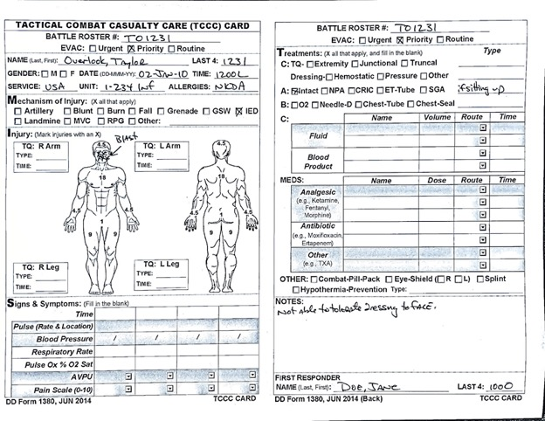

TIER 1 TABLETOP PRACTICE EXERCISE #2 – SITUATION
ID: Timothy Overwatch (Battle Roster # TO1232 and Last 4 of SSN is 1232). Male, U.S. Navy and assigned to Security Force. No known drug allergies (NKDA). Date of Injury: 3 Jan 2010. Time of Injury: 1200L (local).
22 y/o male sailor was a passenger in a MRAP (Mine-Resistant, Ambush-Protected) vehicle when a vehicle-borne IED detonated just prior to impacting the MRAP. The MRAP was lifted into the air and rolled over. After extracting him from the vehicle, he told you that he had no loss of consciousness but severe pain in his right lower leg, mid-back, and left ankle. Your assessment revealed an open fracture of the right lower extremity that was bleeding. You placed a tourniquet proximal to the right knee and put a dressing over the open wound/exposed bone. The left ankle looked dislocated or fractured, but the skin was intact. There was no other evidence of bleeding. The patient was alert, talked in complete sentences, and was asking for some pain medication. The medic came by to start assessing him, but she was called away to care for another patient. She returned quickly and told you to get the patient on a litter and to prepare to hand him off to the flight medics when they arrive. She stated that she expected to have her hands full with the other patient.
As directed, you get the patient on a litter and try to stabilize the lower extremities with his gear, which seems to help with the pain level.
The MEDEVAC helicopter arrives, and the medic is still stabilizing the other casualty. The flight medic is coming over to you. Complete the TCCC card, give your oral handoff using the MIST format, and give the TCCC card to the medic with the patient.
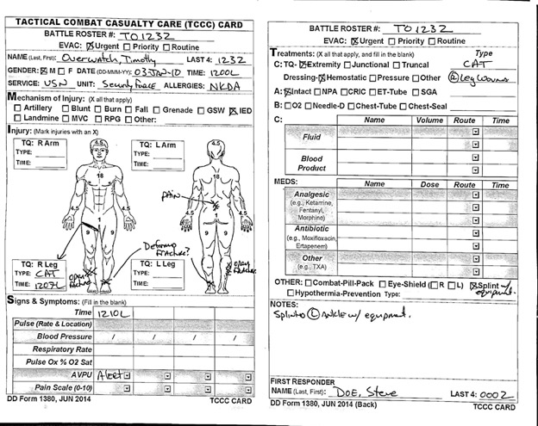

TIER 1 TABLETOP PRACTICE EXERCISE #3 – SITUATION
ID: Tahir Overwatch (Battle Roster # TO1233 and Last 4 of SSN is 1233). Male, U.S. Army and assigned to 1-234 Infantry. Allergy to Penicillin (PCN). Date of Injury: 4 Jan 2010. Time of Injury: 1200L (local).
25 y/o male soldier stepped on a pressure-plate land mine while on a dismounted patrol. He is one of several casualties from this explosion. As you arrived to help him, he was not moving and not responding to your questions. He was lying on the ground, and there was a significant amount of blood on the ground by his legs. His left leg was lying at an odd angle, and blood was coming out of wounds from both legs. You immediately work to place tourniquets on both lower extremities. As you continue your blood sweeps, you find a bleeding wound in the upper left upper extremity and place a tourniquet on the left arm as well. Your assessment of the airway is that the patient’s airway is open but he seems to be taking shallows breaths. You open his airway with a chin lift, resulting in some improvement in the airway. You also find a penetrating wound to the abdomen. You place dressings on the extremity and abdominal wounds. After dressing the wounds, you place the patient in a recovery position. You notice that the patient has an allergy tag for an allergy to penicillin.
The patrol moves a short distance to a hasty landing zone and the MEDEVAC aircraft arrives. The medic is still busy caring for the other casualties as the flight paramedic comes over to you. Complete the TCCC card and give an oral handoff to the flight paramedic using the MIST format. Send your TCCC card with the patient.

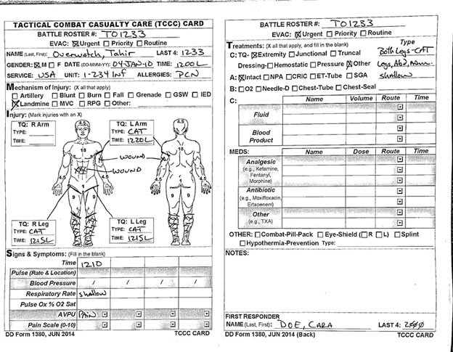

TIER 1 SKILLS CHECK #1 – SITUATION
ID: Tara Overwatch (Battle Roster # TO1234 and Last 4 of SSN is 1234). Female, U.S. Army and assigned to 1-234 Infantry. Drug Allergy to Sulfa. Date of Injury: 5 Jan 2010. Time of Injury: 1200L (local).
48 y/o female in your squad sustained multiple gunshot wounds to the right chest and right upper thigh when your dismounted patrol was ambushed outside the base. After your squad maneuvered through the ambush, you returned to assist the wounded and you found her applying a tourniquet to her right upper thigh. She was alert, quite vocal with her frustration at being injured, but complaining of difficulty breathing. Your assessment revealed a gunshot wound to the right chest without evidence of an exit wound and gunshot entrance and exit wounds to the right thigh. The tourniquet had effectively stopped the bleeding in her thigh. There is a moderate amount of blood on the ground under her leg. You secure a dressing over the wound on the side of her chest and put a dressing over the gunshot wounds on the thigh. While awaiting plans to move her to a centralized location, you fill out the TC3 card. The patient had an allergy dog tag that says she is allergic to Sulfa.
Your platoon medic heads your way to check on your patient and to see if you need assistance. He wants to consolidate all the patients at the CCP (Casualty Collection Point) to prepare them for evacuation. You work together to move the patient to the CCP, but you are needed back on the line for security, as your leadership is concerned about another attack. The medic quickly reviews your TC3 card and asks you for a handoff brief. Please give an oral handoff to the medic using the MIST format.

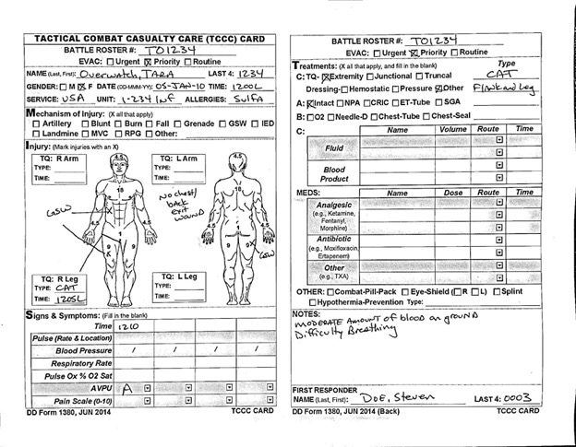

TIER 1 SKILLS CHECK #2 – SITUATION
ID: Taavon Overlord (Battle Roster # TO1235 and Last 4 of SSN is 1235). Male, U.S. Army and assigned to 1-234 Infantry. No known drug allergies (NKDA). Date of Injury: 6 Jan 2010. Time of Injury: 1300L (local).
You were on patrol when your medic, a 25 y/o male, seemed to disappear in a cloud of dust 30 feet in front of you. After the dust settled, it was clear that your squad was struck by an improvised explosive device (IED). Once the scene was secure, you moved to him and were the first person at his side. You found his left lower leg was completely blown off at the level of the mid-shin, and his right leg is flopping around with an open fracture and bones sticking out. He appeared confused but responded to your voice. He was not answering your questions. You place tourniquets on both legs, but it appears that he lost a lot of blood before you got the tourniquets on. Your squad leader coordinates for a litter to be assembled, and you and your teammates move him to cover. You complete your blood sweeps and find no additional bleeding or wounds. Evacuation is delayed due to security, and the decision is made to move him by ground back to the base. In the back of the truck, you do your best to put dressings on the left leg stump and right leg wound and keep him warm with a wool blanket.
You arrive at the aid station. Fill out the TCCC card and hand off the patient to the Battalion Surgeon using the MIST form.

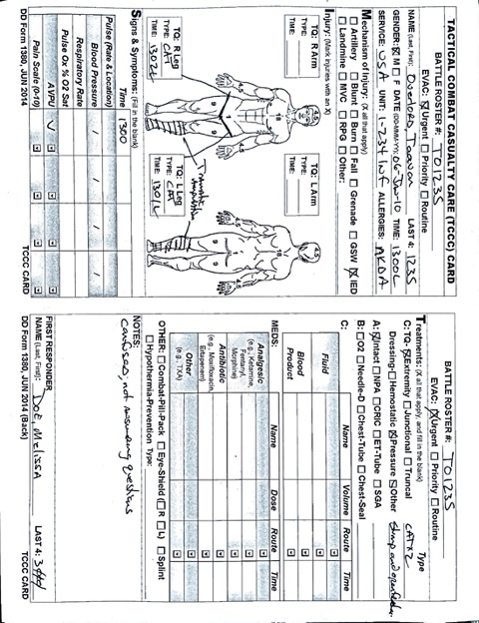

TIER 1 INSTRUCTOR ASSESSMENT SHEETS

TIER 1 SKILLS CHECK #1 ASSESSMENT FORM
Training Date: _____________ Instructor Name: _______________
Sender ID:_________________ Receiver ID:____________________
Instructions: Check off the items you hear in the verbal handover to the items listed below.
MIST REPORT
DD1380 Section | Critical Items | Sender | Receiver
- Mechanism  (__ Item total) | Multiple gunshot wounds sustained from ambush
- Injury  (__ Items total) | Gunshot wound to right thigh
- Injury  (__ Items total) | Gunshot wound to right side of the chest
- Signs/Symptoms  (__ Items total) | Conscious/alert/speaking
- Signs/Symptoms  (__ Items total) | Severe bleeding/loss of blood
- Signs/Symptoms  (__ Items total) | Difficulty breathing
- Treatment  (__ Items total) | Tourniquet on right leg
- Treatment  (__ Items total) | Dressing placed on right flank
- Treatment  (__ Items total) | Dressing on right thigh
Critical items total:
Additional Comments and Observations:

TIER 1 SKILLS CHECK #2 ASSESSMENT FORM
Training Date: _____________ Instructor Name: _______________
Sender ID:_________________ Receiver ID:____________________
Instructions: Check off the items you hear in the verbal handover to the items listed below.
MIST REPORT
DD1380 Section | Critical Items | Sender | Receiver
- Mechanism  (__ Item total) | Command-detonated IED
- Injury  (__ Items total) | Right lower limb traumatic amputation/blown off
- Injury  (__ Items total) | Left leg open fracture, bones sticking out
- Signs/Symptoms  (__ Items total) | Confused/responding only to voice stimuli
- Signs/Symptoms  (__ Items total) | Severe bleeding/loss of blood
- Treatment  (__ Items total) | Tourniquet on left leg
- Treatment  (__ Items total) | Tourniquet on right leg
- Treatment  (__ Items total) | Placed dressing on stump of R leg amputation
- Treatment  (__ Items total) | Placed dressing on L leg wound
Critical items total:
Additional Comments and Observations:

SKILLS CHECK SCENARIO # _____________ (Use this form if creating your own scenario. Add # of critical item total for each section in DD1380 section and critical items in Critical Items column.)
Training Date: ______________ Instructor Name: _______________
Sender ID:__________________ Receiver ID:____________________
Instructions: Check off the items you hear in the verbal handover to the items listed below.
MIST REPORT
DD1380 Section | Critical Items | Sender | Receiver
- Mechanism
(__ Item total)
- Injury
(__ Items total)
- Signs/Symptoms
(__ Items total)

- Treatment
(__ Items total)
Critical items total:
Additional Comments and Observations:

Handoff Skills Assessment Form (Use with any scenario)
- Do the receiver and sender use closed-loop communication?

 | Receiver verbally acknowledges message was received. |  | Recipient verbally acknowledges and repeats back task-related message. |  | Recipient verbally acknowledges and repeats back message accurately and completely; verbally requests clarification or verification from the sender when needed.
Receiver

 | The sender initiated the handoff without asking if the receiver was ready to initiate. |  | The sender asked the receiver if they were ready for the handoff, but did not acknowledge questions/concerns from the receiver or did not close the loop. |  | The sender asked if the receiver was ready for the handoff and acknowledged questions/concerns of the receiver or closed the loop.
Sender

- Please rate the degree to which a transfer of responsibility occurred during the handoff:

 | Current care provider and subsequent care provider did not confirm transfer of responsibility. |  | Current care provider confirmed transfer of responsibility, but subsequent care provider did not confirm retrieval of responsibility. Vice versa. |  | Both current and subsequent care providers confirmed transfer of patient care responsibility.
Transfer of responsibility:

- Please rate the degree of completion and reception of the handoff form:

 | The sender did not complete the patient information form and the form was not handed over to the receiver. |  | The sender completed the patient information form and did not hand it to the receiver. |  | The sender completed the patient information form and handed it over to the sender.
Completion and reception of handoff form:

- Did the receiver ask the sender any clarifying questions about the handover?
  - Yes
  - No

What clarifying questions were asked? ____________________________________________________________________________________________________________________________________________________________________________________________________________________________________________________________________________________________________________________________________________________

